**How do I change the label size in LABEL MATRIX?**

Environment

* Windows XP SP3
* Windows Vista
* Windows 7
* Windows 8
* Windows Server 2003
* Windows Server 2008
* Windows Server 2012

**Resolution**

1. **Click the File menu.**
2. **Click Page Setup.   
     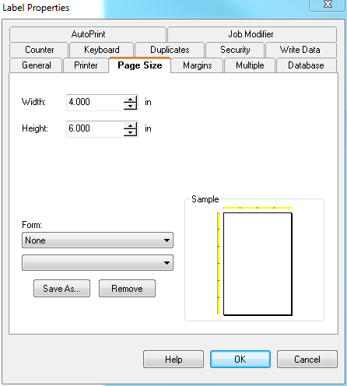**
3. **Click on the Page Size tab and set the Width and the Height.**
4. **Click the Margins tab and set the Left, Right, Top, and Bottom margins.**
5. **Click OK to finish.**